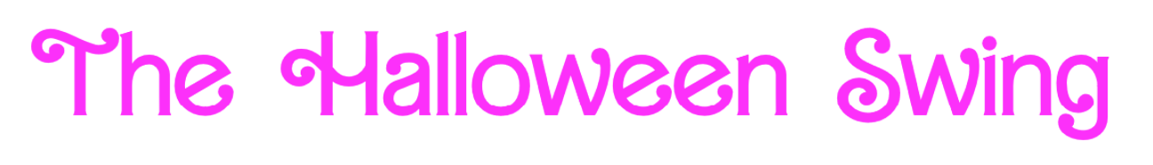
Welcome to Halloween Swing 2023: Barbenheimer!

Here are a few reminders and important details:
- Breakfast and lunch will be provided to all judges and competitors, but there are also lots of delicious places around campus within driving and delivery distance.
- No specific warm up rooms are designated - Please find any open room in the building.
- Registration is on the first floor of ASH at 8:45am; Extemp Draw at 9.
- SOME spaces in this building may contain decorations with flashing lights. Please proceed with caution and talk to the tournament staff with any needs or concerns here.
- Halloween Swing Fun
  - There is a puzzle on the second floor - follow the instructions opposite the elevator…
  - Mini-Duck Scavenger Hunt - collect the most and win a prize!
  - Pin the Sunglasses on the Ken - happening during lunch in the main hallway
  - Student Lounge Crafts - let your Craft Barbie enjoy sash-making and coloring stations in ASH101
  - PHOTO OPPORTUNITIES!
    - Check out the Student Lounge, Main Hallway, Extemp Draw, and lots of other places in the building for photo fun today. Tag UNO and Doane on any socials and send us your favorites from the day!
- ROOMS
  - Extemp Draw: Room 181
  - Judges Lounge: Room 143
  - Student Lounge: Room 101
  - Quiet Room: Room 392
  - Tab Room: 110/112

